Before Added new patient:

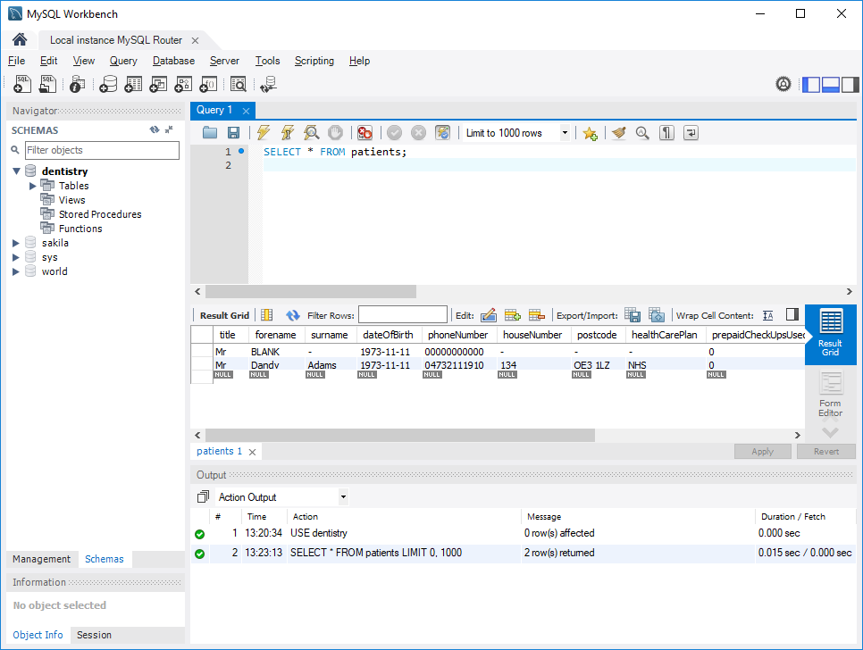

Adding new Patient and adding to NHS free plan:

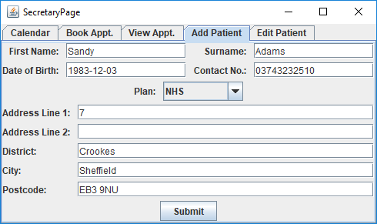

After Added Patient, Mrs Sandy Adams is added:

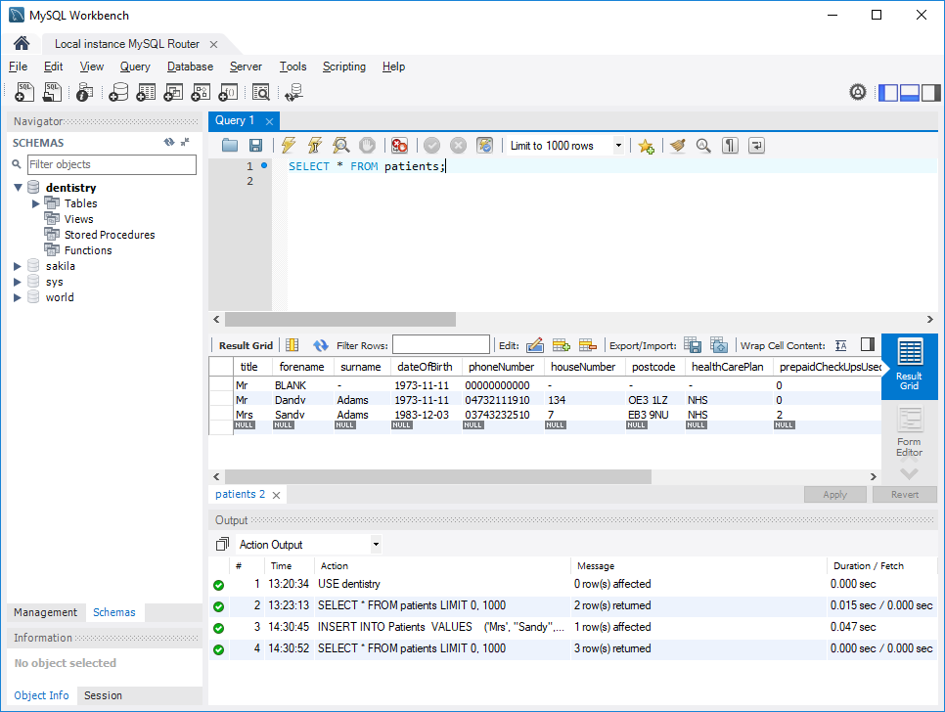

Before Appointment is added:

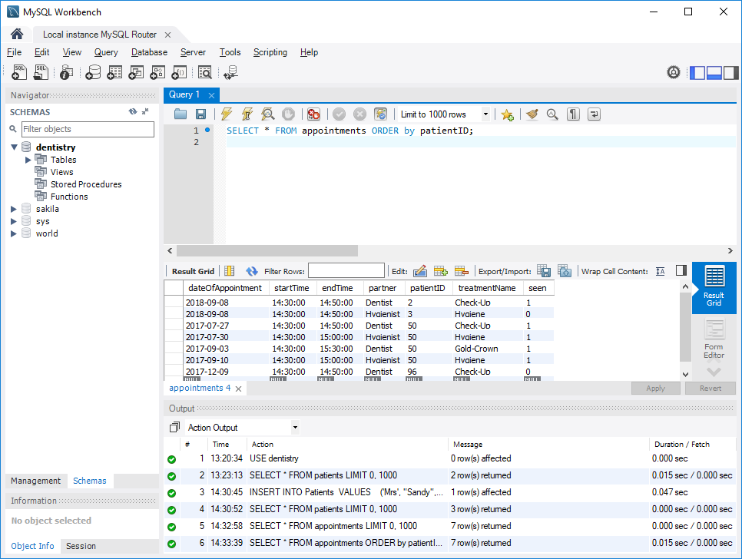

Adding Appointment: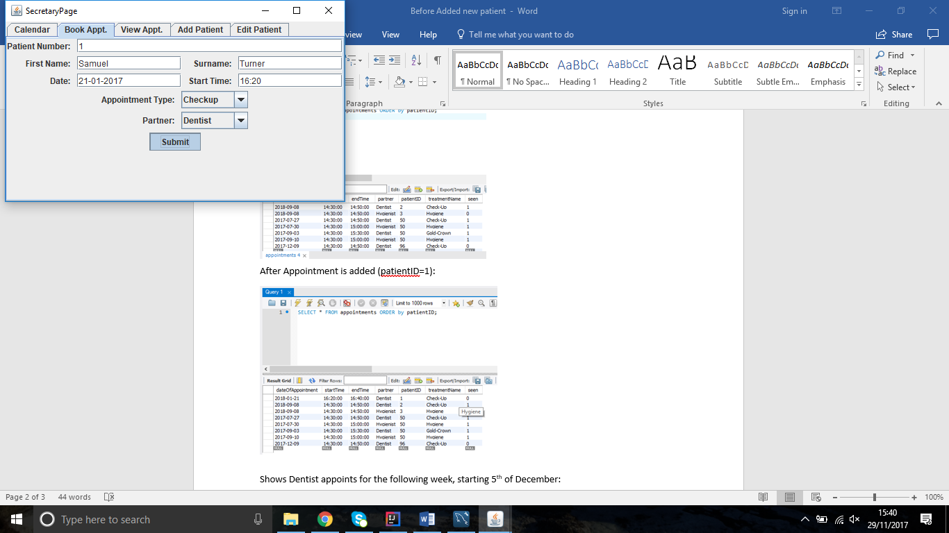

After Appointment is added (patientID=1):

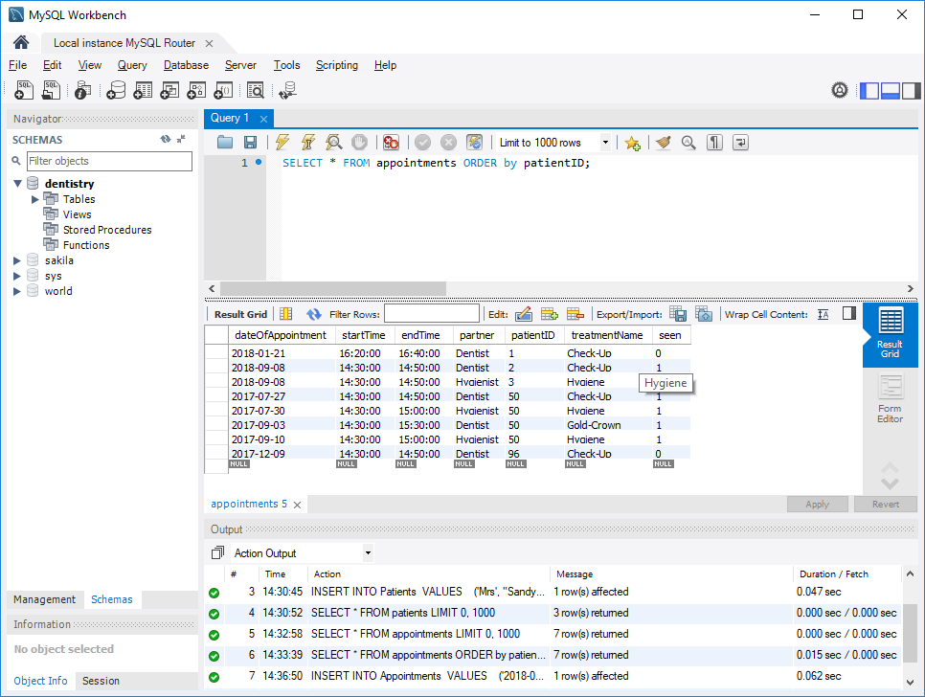

Shows Dentist appoints for the following week, starting 5th of December:

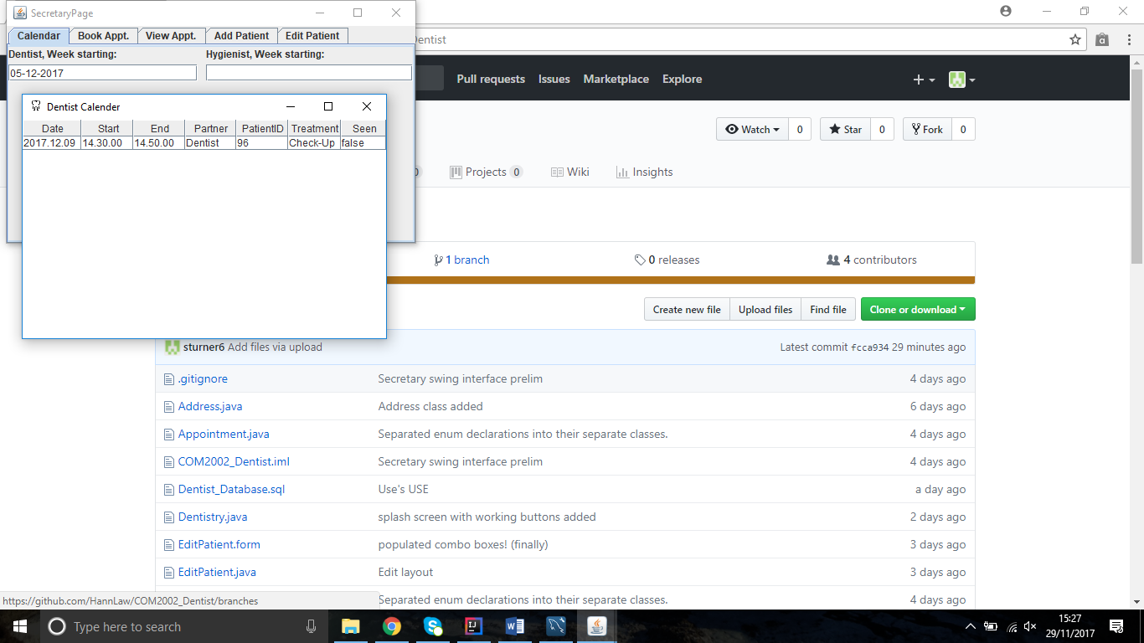

Shows Dentist appoints for the following week, starting 9th of September:

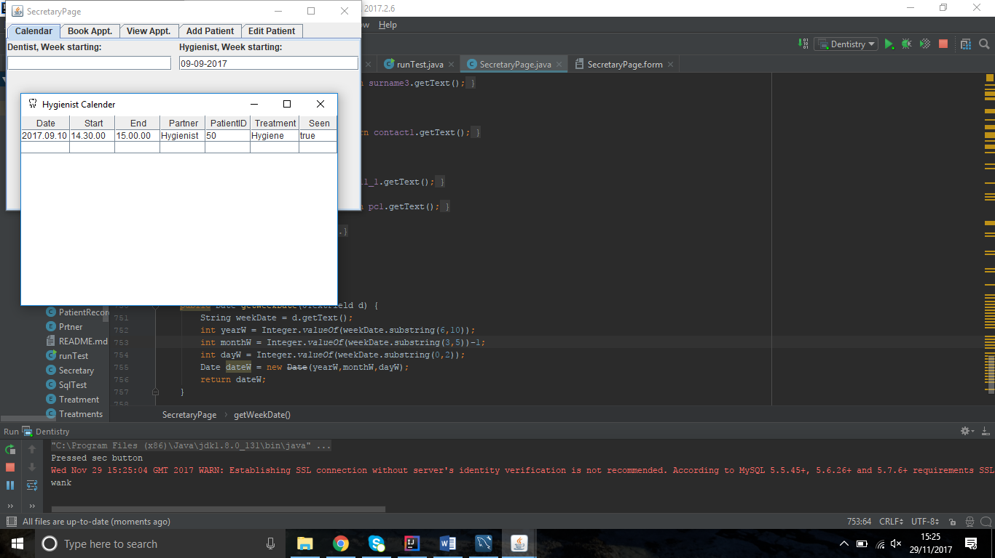

Add 2 days holiday for Hygienist:

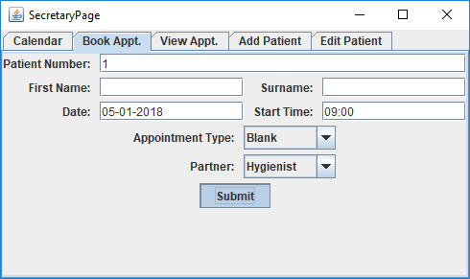

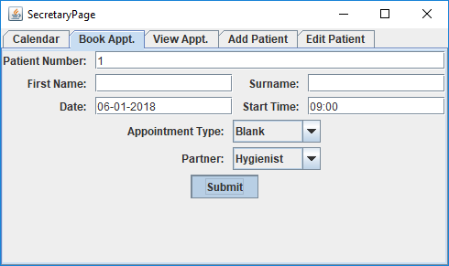

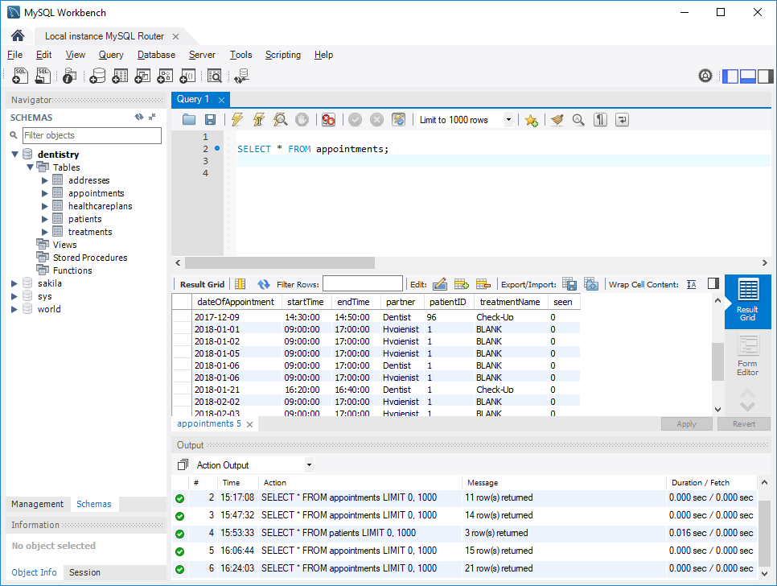Holiday added in database 5th and 6th of January 2018:

Books appointment at 2pm on 20th of January 2018 for Dentist:

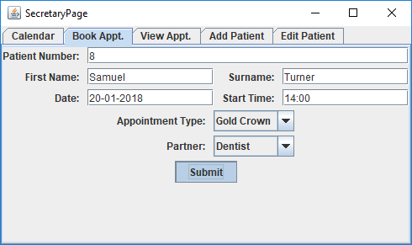

Tries, and fails to book an appointment for the same time with Dentist:

